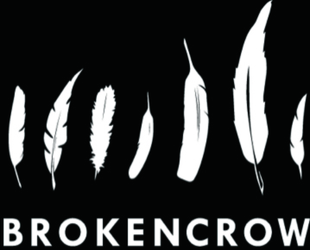

**Child Safeguarding Statement**

Created December 2016

Reviewed Oct 2025

**Statement**

BrokenCrowTheatre Company is committed to placing respect for all people at the centre of our work but with particular commitment in the case of our work for young audiences, to respecting young people and vulnerable adults.

We commit to respecting their intelligence, sensitivity, capacity for learning and opinions and we undertake to provide a safe experience and positive environment in our work for their physical and emotional safety.

We wish the young people we work with to enjoy the experience, to explore challenges, to have fun, to reflect seriously and, above all, to engage with the art forms of drama and theatre.

We will adhere to the recommendations of *Children First: National Guidance for the Protection and Welfare of Children (2011)*. We have developed policies and procedures to ensure that this commitment is enshrined in all aspects of our company.

This policy is targeted at all adults involved in our company, be they staff or volunteers. All staff and volunteers will be informed of relevant policies and procedures as they relate to their participation.

The policies and procedures in this document have been designed so that their implementation will protect both young people and staff and allow everyone to focus on quality of engagement, participation and creativity.

We have also committed to review our policies and procedures on an annual basis. This policy was created in December 2016 and will be reviewed again in July 2026.

Signed ___